# **Prioritizing Maintenance Work**

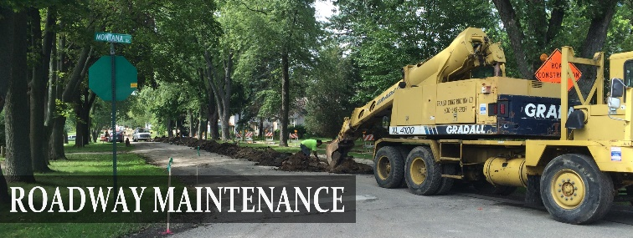

As you are aware, you often have multiple roadway maintenance projects that are either in various stages of progress, or you have a “waiting list” of projects that need to be done. The big question is – “how do I select what project to take on first and then in what order the others that are waiting?”

Image courtesy of Illinois Department of Transportation

Many transportation infrastructure organizations use a “biggest itch gets scratched first,” or a “fly by the seat of the pants” approach. Neither of these approaches will ever give you the results you and your constituents seek. You will always have citizens asking why one project was taken on and completed ahead of the project that impacts them the most – a road they drive daily.

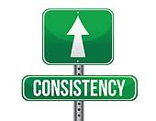

Having a systematic and consistent approach to how you prioritize your projects for completion will provide numerous benefits such as:

* Keeping your projects on schedule and budget plus being able to have a

defensible explanation of why projects were done in the order based on data.

## ***Different Types of Roadway Maintenance***

The following definitions of roadway maintenance are taken from the Texas Department of Transportation’s Maintenance Operations Manual that can be accessed at [Maintenance Operations Manual (OPE) (txdot.gov)](http://onlinemanuals.txdot.gov/txdotmanuals/ope/ope.pdf)

***Routine maintenance*** - consists of work planned and performed on a routine basis to maintain and preserve the condition of roadways or to respond to specific conditions and events that restore the roadway to an adequate level of service.

***Preventive maintenance*** - planned strategy of cost-effective treatments to an existing roadway system and its appurtenances that preserve the system, retards future deterioration, and maintains or improves the functional condition of the system.

***Major maintenance*** - work to strengthen the roadway, structure, or facility for the current and projected future traffic usage. Performed to correct a maintenance or safety problem or to protect public or private property.

## ***Prioritization Classifications***

No matter what type of roadway maintenance you are undertaking, prioritizing it is important. A step to help you determine prioritization of each project, let’s look at some task examples:

***EMERGENCY*** work task would be a downed stop sign at an intersection to avoid a potential vehicle crash. It may also include responses to reopen closed roads blocked by storm debris.

***URGENT*** work task would be grading a road to make it passable after a heavy rain event.

***IMPORTANT*** work task would be filling potholes on a low-traffic volume road.

***ROUTINE*** work task would be mowing the county ROW, installing culverts, etc.

***PLANNED*** project will typically take longer, will be a major upgrade, and can have significant costs attached. An example would be rehabilitating a section of county road from an oil-sand composition to a compacted and chip-sealed surface.

## ***Six Steps to Help Prioritize***

Extracted from a blog by Liquid Planner ([How to Prioritize Work When Everything Is #1 | LiquidPlanner](https://www.liquidplanner.com/blog/how-to-prioritize-work-when-everythings-1/)) is figuring out which prioritization category your project falls into.

1. Write down a list of all work tasks/activities. Pull together everything you could consider that needs to be done. Don’t worry about the order or the number of items. Items to think about are calls from citizens, potholes needing to be fixed, roads to be graded, signs or markers down and/or missing, mowing, preventive maintenance on equipment, etc.
2. Identify emergency vs. urgent vs. important vs. routine vs. planned. The next step is to see if you have any tasks that need immediate attention. We’re talking about work that will have serious negative consequences if not completed by the end of the day or in the next couple of days. These are your Emergency and Urgent categories. Let **SAFETY** always be your guide for task prioritization.
3. Assess value. Next, look at your important, routine, and planned work projects and identify what carries the highest value to your county or precinct. As a general practice, you want to recognize precisely which types of tasks have top priority over the others. For example, focus on client projects before internal work, such as fixing potholes before preparing for a non-critical meeting. Another way to assess value is how many people are impacted by your work. In general, the more people involved or impacted, the higher the stakes.
4. Order tasks by estimated effort. If you have tasks that seem to tie for priority standing, check their estimates and start on whichever one you think will take the most effort to complete. Productivity experts suggest the tactic of starting the lengthier task first. But, if you feel like you can’t focus on your more time-consuming projects before you finish up the shorter task, then go with your gut and do that. It can be motivating to check a small task off the list before diving into deeper waters.
5. Be flexible and adaptable. Uncertainty and change are given in roadway maintenance operations. Know that your priorities will change, and often when you least expect them to. But—and here’s the trick—you also want to stay focused on the tasks you’re committed to completing.
6. Chart, bar chart

   Description automatically generatedKnow when to cut. You probably can’t get to everything on your list as quickly as you would like to. It’s OK – quality road maintenance is not a race you win quickly. After you prioritize your tasks and look at your estimates, move the remaining tasks to the bottom of your list, and focus on the priorities that you know you must and can complete in as a reasonable time possible.

## ***Putting it Together***

Many Project Managers use the Lean Prioritization Matrix to quickly identify which work tasks or projects will provide the highest value (impact) with minimum difficulty and/or cost. Using this matrix helps to take the guesswork out of decisions.

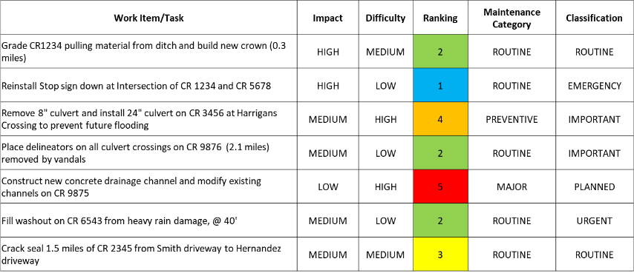

Image courtesy of R.L. Belk Consulting, LLC

When you put

Image courtesy of R.L. Belk Consulting, LLC

together all of

the components of planning and prioritizing your various work items and projects, your plan may look like this. A simple drawing on a whiteboard in a precinct yard office or an Excel spreadsheet will always keep you on task!